**M S Ramaiah Institute of Technology**

(An Autonomous Institute,Affiliated to VTU)

MSR Nagar, MSRIT post, Bangalore-54

A Dissertation Report on

**SKIN COLOUR SEGMENTATION**

Submitted by

JAYANTH .B 1MS12CS041

N.VEERESHA 1MS12CS063

G KIRAN KUMAR 1MS12CS031

DHARSHAN B.C 1MS12CS027

*in partial fulfillment for the award of the degree of*

# *Bachelor of Engineering in Computer Science & Engineering*



**DEPARTMENT OF COMPUTER SCIENCE & ENGINEERING**

**M.S.RAMAIAH INSTITUTE OF TECHNOLOGY**

**(Autonomous Institute, Affiliated to VTU)**

**BANGALORE-560054**

[www.msrit.edu](http://www.msrit.edu), **May 2015**

# Abstract

In this study using the artificial neural network method of artificial intelligence techniques, using the pixel values of color which were obtained from people who belong our data such as RGB (REDGREEN-BLUE), we realized classification process as the skin or non-skin form of people's image. There are 3 entries in the artificial neural network. Hidden layers are included in our system. The skin of the dataset is collected by randomly sampling the R, G, B values from face images of various age groups (young, middle, and old), race groups (white, black, and Asian), and genders obtained from FERET database and PAL database . Total learning sample size is 245057; out of which 50859 is the skin sample and 194198 is non-skin samples. These 3 input reach our 10-layer hidden layer at our net and from here by processing a classification process is done. Classification of artificial neural network of 245057 data are determined as successful as set of real data classification. Regression results of classification process is quite high. Training regression R = 0.99123, test regression R= 0.99056 and validation regression are defined as 0.99131. With the artificial neural networks in the classification process has been shown to be achieved outstanding success.

**Keywords:** ANN, classification, artificial neural network, skin, non-skin, machine learning database, RGB.

#### Contents

***Declaration i***

***Acknowledgements ii***

***Abstract iii***

***List of Figures***

***List of Tables***

1 **INTRODUCTION**

* 1. General Introduction………………. **5**
  2. Statement of the Problem………….. 6
  3. Objectives of the project…………… 7
  4. Project deliverables…………… 8
  5. Current Scope……………………… 8
  6. Future Scope………………………. 9

1. **PROJECT ORGANIZATION**
   1. Software Process Models 10
   2. Roles and Responsibilities 12
2. **LITERATURE SURVEY**

3.1….Introduction 13

3.2…Main Body 14

3.3 Conclusion of Survey 16

1. **SOFTWARE REQUIREMENT SPECIFICATIONS**

5.1 Product Overview 18

5.2 External Interface Requirements 20

5.2.1 User Interfaces

5.2.2 Hardware Interfaces

5.2.3 Software Interfaces

5.2.4 Communication Interfaces

5.3 Functional Requirements 23

5.3.1 Functional Requirement 1.1

:

5.3.n Functional Requirement 1.n

5.4 Software System Attributes 24

5.4.1 Reliability

5.4.2 Availability

5.4.3 Security

5.4.4 Portability

5.4.5 Maintainability

5.4.6 Performance

5.5 Performance Requirements

5.6 Database Requirement

5.7 Design Constraints

5.8 Other Requirements

1. **DESIGN**
   1. Introduction 24
   2. Architecture Design
   3. Graphical User Interface
   4. Class Diagram and Classes
   5. (represent Inheritance, Aggregation and Association)
   6. Sequence Diagram
   7. Data flow diagram
   8. Metric calculation
2. **IMPLEMENTATION 25**
   1. Tools Introduction
   2. Technology Introduction
   3. Overall view of the project in terms of implementation
   4. Explanation of Algorithm and how it is been implemented
   5. Information about the implementation of Modules
3. **TESTING**

**7.1** Results and Snapshots 31

1. **CONCLUSION & SCOPE FOR FUTURE WORK 35**
2. **REFERENCES 36**

**Introduction**

**General introduction:**

At present time one of security elements which has great importance for countries is the people's face recognition system. In such systems, determination of parts whether skin or non-skin will allow for easier recognition and image processing techniques in computer. Color space-based models act as efficient approaches for quickly identifying the skin-like regions before performing complicated steps like face and body detection and tracking. Various color space-based approaches have been proposed by researchers (Albiol, Torres and Delp 2001; Brand and Mason 2000; Chai and Bouzerdoum 2000; Gomez 2000; Terrillon et al. 2000). However, skin region segmentation for embedded systems porting needs separate attention because of processing limitations of the devices (Rajen et al. 2009). Collected skin dataset by randomly sampling B,G,R values from face images of various age groups (young, middle, and old), race groups (White, Black, and Asian), and genders obtained from FERET database and PAL database (Color FERET & PAL Face). Psychological case evaluation is a study depending on facial expression recognition. On account of an ability of facial expression recognition, there are individual differences even in between people. Classification can be defined simply as regulation of objects in certain groups based on their similarities. In this study using artificial neural networks was carried out the classification process. In Skin segmentation classification (SSC) process UCI Machine Learning Repository (Center for Machine Learning and Intelligent Systems located in (http://archive.ics.uci.edu/ml/datasets.html) utilizing the classification of Skin Segmentation data set is made . The aim of this study is to perform the classification task of data mining and artificial neural network method with information about our dataset.

**Problem statement:**

What we need is a function which can tell whether a given colorpixel is a skin pixel or not.

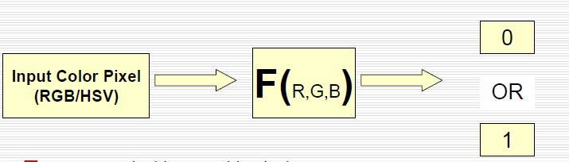

0 : Input pixel is not a skin pixel

1 : Input pixel is a skin pixelInput

**Objectives of the project:**

The skin dataset is collected by randomly sampling B,G,R values from face images of various age groups (young, middle, and old), race groups (white, black, and Asian), and genders obtained from FERET database and PAL database. Total learning sample size is 245057; out of which 50859 is the skin samples and 194198 is non-skin samples.

The primary objective of our project is to classify the given data set into skin and non-skin samples by making use of Artificial Neural Networks.

Once our primary objective is achieved, the technique that has been employed can be applied extensively such as face detection in a given image, pre-processing step in various human detection systems, etc.

**Project deliverables:**

A robust system that recognizes face or human body patterns in a given image.

**Current scope:**

Many computer vision applications dealing with the detection and recognition of humans and their activities require the segmentation of skin regions as a pre-processing step. Examples for such systems can be found in the fields of surveillance, human computer interaction and face recognition . Although, color cues have the advantage to be relatively invariant regarding scale and orientation, the utilization of color information is often a challenging task, as in images the appearance of the skin color is dependent on different factors, such as illumination condition, ethnicity, camera characteristics etc.

The reviews by Kakumanu *et al.* andVezhnevets *et al.* illustrate, that an extensive body of work on skin segmentation exists. A minor set of techniques applies explicitly defined color thresholds, which are empirically determined. These approaches are often too inflexible and cannot easily adapt to illumination variations. The largest group of approaches uses machine learning techniques to estimate the probability of skin pixels. Although these approaches are more flexible, their degree of illumination adaptability is sensitive to the training set. Illuminant colors outside the training data cannot be handled well.

Some methods exist that are explicitly designed for handling illumination variations. They can be separated into two categories: a) color-constancy techniques and b) dynamic adaptation techniques. For the first group an estimate of the illuminant color is used to create a new normalized image, where colors are independent of the incident illuminant. In the second group the skin-color model is transformed according to the measured variations in the image colors . Some illuminant adaptive methods have restrictive requirements, as they are constrained to frontal face images or depend on training data and do not explicitly use the illuminant color.

Another group of physics-based approaches analyzes the change of the skin locus under varying illumination. With respect to normalized RGB space, Martinkauppi *et al.* showed that for different illuminant colors the skin pixels lie inside a region which can be bounded by two quadratic functions. Furthermore, Störring *et al.* showed that for a known camera and known color temperature of the illuminant the search area for skin color can be adjusted accordingly. The normalized RGB space has also been used for illuminant-invariant tracking and locating image-specific skin clusters. All prior research on skin locus uses the normalized RGB space which is mathematically more complex and which often makes the explicit knowledge of the illuminant color temperature mandatory. However, the color temperature is more difficult to extract than the illuminant color.

The goal of this project is the development of a robust illumination-adaptive skin segmentation approach. Thereby, the focus is on physics-based skin models.

At present time one of security elements which has great importance for countries is the people's facerecognition system. In such systems, determination of parts whether skin or non-skin will allow foreasier recognition and image processing techniques in computer. Color space-based models act asefficient approaches for quickly identifying the skin-like regions before performing complicated stepslike face and body detection and tracking. Various color space-based approaches have beenproposed by researchers (Albiol, Torres and Delp 2001; Brand and Mason 2000; Chai andBouzerdoum 2000; Gomez 2000; Terrillon et al. 2000). However, skin region segmentation forembedded systems porting needs separate attention because of processing limitations of the devices(Rajen et al. 2009). Collected skin dataset by randomly sampling B,G,R values from face images ofvarious age groups (young, middle, and old), race groups (White, Black, and Asian), and gendersobtained from FERET database and PAL database (Color FERET & PAL Face).Psychological case evaluation is a study depending on facial expression recognition. On account of anability of facial expression recognition, there are individual differences even in between people.Classification can be defined simply as regulation of objects in certain groups based on theirsimilarities. In this study using artificial neural networks was carried out the classification process. InSkin segmentation classification (SSC) process UCI Machine Learning Repository (Center for MachineLearning and Intelligent Systems located in (http://archive.ics.uci.edu/ml/datasets.html) utilizing theclassification of Skin Segmentation data set is made . The aim of this study is to perform the

classification task of data mining and artificial neural network method with information about our data-set.

**Future scope:**

The primary objective of our project is to classify the given data set into skin and non-skin samples by making use of Artificial Neural Networks.

Once our primary objective is achieved, the technique that has been employed can be applied extensively such as face detection in a given image, pre-processing step in various human detection systems, etc.

In future this can be used as a preliminary analysis or check for an image or a scene to conclude if there exists a human face or body in the image or scene.

The performance of human activity analysis can be improvedby considering the occlusion of body poses. Modelling and activity analysis for single and multiplepersons in the outdoor video sequences can be developed.

In future work, we intend to refine the use of morphological operations in the post-processing of the extracted skin regions. An adaptive training (incremental learning) of the skin color model can be used to improve the overall classification of skin regions. Primarily, the elimination of false detections and false dismissals is crucial to the success of a robust face detector.

**Project organization**

**Software process models:**

The model that was employed in our project was Rational Unified Process which is one of the types of Agile Methodology.

Agile methodology:Agile development model is also a type of Incremental model. Software is developed in incremental, rapid cycles. This results in small incremental releases with each release building on previous functionality. Each release is thoroughly tested to ensure software quality is maintained. It is used for time critical applications.  Extreme Programming (XP) is currently one of the most well known agiledevelopment life cycle model.

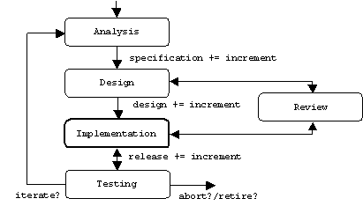

**Agile modeling** is a supplement to other agile methodologies such as Scrum, extreme programming (XP), and Rational Unified Process (RUP). It is explicitly included as part of the disciplined agile delivery (DAD) framework. As per 2011 stats, agile modeling accounted for 1% of all agile software development.

**Rational Unified Process:**The **Rational Unified Process** (**RUP**) is an iterative software development process framework created by the Rational Software Corporation, a division of IBM since 2003. RUP is not a single concrete prescriptive process, but rather an adaptable process framework, intended to be tailored by the development organizations and software project teams that will select the elements of the process that are appropriate for their needs. RUP is a specific implementation of the unified process.

The RUP has determined a project life-cycle consisting of four phases. These phases allow the process to be presented at a high level in a similar way to how a 'waterfall'-styled project might be presented, although in essence the key to the process lies in the iterations of development that lie within all of the phases.

#### Inception phase:The primary objective is to scope the system adequately as a basis for validating initial costing and budgets. In this phase the business case which includes business context, success factors (expected revenue, market recognition, etc.), and financial forecast is established.

#### Elaboration phase:The primary objective is to mitigate the key risk items identified by analysis up to the end of this phase. The elaboration phase is where the project starts to take shape. In this phase the problem domain analysis is made and the architecture of the project gets its basic form.

#### Construction phase:The primary objective is to build the software system. In this phase, the main focus is on the development of components and other features of the system. This is the phase when the bulk of the coding takes place. In larger projects, several construction iterations may be developed in an effort to divide the use cases into manageable segments that produce demonstrable prototypes.

#### Transition phase:The primary objective is to 'transit' the system from development into production, making it available to and understood by the end user. The activities of this phase include training the end users and maintainers and beta testing the system to validate it against the end users' expectations. The product is also checked against the quality level set in the Inception phase.

**Roles and responsibilities:**

Our team consists of 4 members. All the work was divided almost equally among 4 of us.There was no explicit team leader or such. All the 4 members had an equal opportunity to frankly give their opinions. All of us were equally involved in the coding and development process. However, documentation of the project work was divided among 2 of us and the task of writing the paper was assigned to the other 2 team members.

**Literature survey**

**Introduction:**

The face is our primary focus of attention in social life playing an important role in conveying identity and emotions. We can recognize a number of faces learned throughout our lifespan and identify faces at a glance even after years of separation. This skill is quite robust despite of large variations in visual stimulus due to changing condition, aging and distractions such as beard, glasses or changes in hairstyle.

Our aim, which we believe we have reached, was to develop a method of face recognition that is fast, robust, reasonably simple and accurate with a relatively simple and easy to understand algorithms and techniques. The examples provided in this paper are real-time and taken from our own surroundings. Face detection is the first step of face recognition as it automatically detects a face from a complex background to which the face recognition algorithm can be applied. But detection itself involves many complexities such as background, poses, illumination etc. There are many approaches for face detection such as, color based, feature based (mouth, eyes, nose), neural network. The approach studied and applied in this paper is the skin color based approach. The algorithm is pretty robust as the faces of many people can be detected at once from an image consisting of a group of people.

In recent years there has been a growing interest in the problem ofskin segmentation, which aims to detect human skin regions in animage. Skin segmentation is commonly used in algorithms for facedetection hand gesture analysis , and objectionable image filtering . In these applications, the search space forobjects of interest, such as faces or hands, can be reduced throughthe detection of skin regions. To this end, skin segmentation is veryeffective because it usually involves a small amount of computation

andcan be done regardless of pose. Most existing skin segmentation techniques involve theclassification of individual image pixels into skin and nonskincategories on the basis of pixel color. The rationale behind thisapproach is that the human skin has very consistent colors whichare distinct

from the colors of many other objects. In the past fewyears, a number of comparative studies of skin color pixelclassification have been reported. Jones and Rehgcreated thefirst large skin database—the Compaq database—and used theBayesian classifier with the histogram technique for skin detection. Brand and Mason compared three different techniques on the

Compaq database: thresholding the red/green ratio, color space mapping with 1D indicator, and RGB skin probability map.Terrillon et al. Compared Gaussian and Gaussian mixturemodels across nine chrominance spaces on a set of 110 images of30 Asian and Caucasian people.

The difficulty of skin detection is due to the variation of people’s race where each race has a different skin tone from the others. The difference in people’s skin is notthe only problem as there other factors such as the light conditions where the variation inluminance limits the accuracy of skin segmentation.There are many skin color spaces like RGB, HSV, YCbCr, YIQ, YUV, etc. that are used forskin color segmentation. The RGB color model represents the colors that are in the red, green,and blue planes and does not separate the luminance from the chrominance components, which

makes it a poor choice for color analysis and color based recognition . The conversion fromRGB color space to the HSV color model is time consuming due to the time it takes to do a nonlineartransmission . To overcome the previous problems, we have proposed a new threshold, which is based on the YUV and RGB color spaces. Our approach is able to benefit from thecharacteristics of each color model for enhancing the accuracy of skin detection.

**Main body:**

**The concept of color:** The color is a sensation which comes into by reaching different wavelengths of light to retina of eye.The perception of color by the human body realize with reflection of light through objects and subject'stransmitting to the brain thanks to the help of the eyes This perception varies because of detectionlight on the material and they partly absorb and partly reflect. And this is called as color shade or color.If all wavelengths simultaneously reaches the eye, it is perceived as white but if it does not reach anylight, it is perceived as black (Metlek 2009). Colored images are displayed as a 24-bit data in thecomputer screen. Displaying occurs by transmitting of the image which is as red, green, blue, threegray-level encoded which has the same object on top of the screen. In the electromagnetic spectrum0.4-0.5 mm wavelength corresponds to blue; 0.5 to 0.6 mm wavelength corresponds to green; 0,6-0,7mm wavelength corresponds to red. If the three 8-bit image which is obtained from this wave lengthreflect to computer screen respectively as red-green-blue, colored image can be obtained (Russ1999). At Grayscale images occur images of different grayscale values. Grey value range isexpressed as S = {0,1, 2, ..., 255}. What this means is that the value of 256 different shades of gray in

a grayscale image can be found rather different gray values (Diamond 2003). 256 gray values can be defined as a byte, 1 byte = 8 bits and 28 corresponds to 256. 0 gray value as a rule corresponds toblack color, the gray value of 255 corresponds to white. These values are formed between the graytones.

**Artificial neural network:**present information classification and interpretation of information found in (Diamond 2003). 2022Primary output neurons are called as the neurons which take input signal at biological neural network,interprets and transmits the appropriate output. A neuron, consists of three parts as body (cell body),receivers (dendrites) which enter the body signal and the signal transmitting from the body (axon). Artificial neural networks, in general, according to the network; as feedforward and feedback doubled,according to the learning rule; can be divided into 4 including as Hebb, Hopfield, Delta and Kohonen,according to the learning algorithm; supervised, unsupervised and 27 reinforced can be divided into 3;according to practice can be divided into 2 as off-line and on-line . In addition, according to beingsymmetric or asymmetric of the weight matrices, being fixed or variable of the value of weight matrix,located on the characteristics of the network node, being deterministic or stochastic activation function

can be classified. Feedforward networks in pattern recognition problems are widely used in the Artificial neural network model which consists of our system is shown in Figure

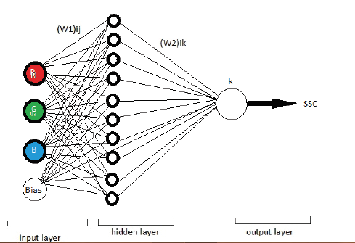

**ARTIFICIAL NEURAL NETWORK APPLICATION ON DATASET:**Here, the following transactions were carried out to determine whether it is skin or not from the dataset of 245 057 color pixels:

a. Random number 36759 (15%) was selected as our test data.

b. Random number 36759 (15%) data is selected as the data validation.

c. The remaining 171 539 units (70%) was selected as the training data.

In this study, a feed forward network structure that contains an input layer, a hidden layer and an output layer (Fig. 1) was used. After the ANN structure was designed, the data obtained in theexperimental study were normalized in the 0-1 value set using Eq. 1 in order to improve thecharacteristics of the training. The Back Propagation algorithm was used in the training procedure.Different transfer functions (Purelin, Tansig, Logsig etc.) were used and tried in the neurons in thehidden and output layers and (Tansig) was selected as the transfer function that yielded the bestresult.

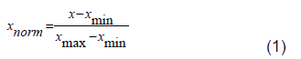

The training data set was used to determine ANN neuron and bias weight values. Training wasrepeated to obtain the lowest level of error by changing the number of neurons and the epoch number.Then, the trained algorithm was applied on the test data set. First, by giving different values in the hidden layer, network is trained and the results have beenobserved. For 10-layer network in the hidden layer that the best results are obtained is seen.

At the end of these Procedures, the network structure that yielded the best classification is given in the table given below.

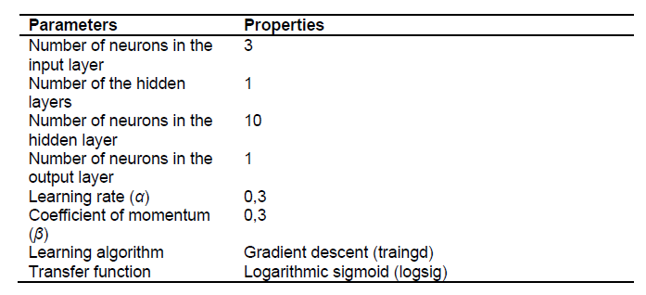

**Conclusion of survey:**

Skin color segmentation is an important and challenging problem for many of the image processing and computer vision applications. To achieve better skin detection for images withcomplex backgrounds and different brightness, a new approach that is based on the RGB andYUV color spaces has been described. The results show that the proposed method can achieve a

high skin detection rate compared to the other methods. In future work, other features, such as texture, will be used for more accurate detection in dealing with more complex backgrounds andcolored hair that is similar to the skin color pixels.

**Software requirement specification**

**Product overview:**

A robust system that recognizes face or human body patterns in a given image.Our data set is first normalized using HADOOP and Map Reduce techniques. The normalized data set is then partitioned into training and testing set using CARET(Classification And Regression Analysis) package.

The training data set is used to train the layers of the artificial neural network. Initially a small amount of error is present in the output when compared to the actual output. This is rectified using a technique known as Regression Analysis. Finally, the trained layers are fed with the testing data to analyze the output. Here we find that the output obtained will be as per the required output.

The final product then identifies the human skin or body in an image or a scene when an image is given as the output.

**External interface requirement:**

**External Interface Requirements**

**User Interfaces :** The software provides a simple interface where users will be able to specify location of the color file. The predicted class will be displayed at the bottom.

**Hardware Interfaces**: Cluster of machines if the user wants to take advantage of parallel processing otherwise none.

**Software Interfaces** : The software communicates with Apache Hadoop. It uses HDFS for storing files and Map reduce framework for parallel processing.

**Communication Interfaces:** The software communicates internally with the main network module and other modules.

**Functional requirements:**

**Cleaning the Data:** The input data will be checked to eliminate rows with empty or bad color values.

**Test/Train Split:** The software splits the input data randomly into training and testing data.

**Normalize the data:** The software normalizes the training the data to have mean 0 and SD of 1

**Train the model:** The software trains the neural network model using the training data.

**Apply the model:** The trained model is applied to the test data and results are obtained.

**Software System Attributes**

**Reliability:** We have included different race’s skin samples like Asian etc for training the model. So, the system is highly accurate in predicting the result.

**Availability**: The software will be available at all times.

**Security:** There are no security issues with this system as there is no confidential input and does not access files in hdfs apart from the ones it requires for training and testing.

**Portability:** The software can be used on any operating system as there no OS specific code as long as that OS is supported by Hadoop.

**Maintainability:** The Code is modularized and can be modified easily. It is written in such a way that new features can be implemented easily.

**Performance:** Performance of the software depends on the extent of parallel processing involved and power of systems involved for parallel processing. The algorithms are optimized to provide the best performance.

**Performance Requirements :** The user can run the software either in a cluster to exploit parallel processing or in a single machine. Running in cluster will have performance benefits like lesser computation time etc compared to running in single machine. Machines with adequate processor speed and memory are needed for fast computations.

**Database Requirement:** There is no requirement for a database for the operation of this software

**Design Constraints**: The major constraint is OS. Since Hadoop only works in some OS, the software is limited to such OS. Sufficient space is needed in the Hadoop File System for the storage of training data.

**Other Requirements:** There are no other requirements.

**Design**

**Introduction:**

The whole system is built on the Artificial Neural Networks. HADOOP has been made used to implement the normalization of the data set. Coding is done using a programming language known as R on a platform known as R studio.

Number of Modules : There are 4 modules used.

Modules description:

1) Normalizing module: The preprocessing module normalizes the data.

2) Splitting module: Splitting module splits the input data into testing and training data.

3) Neural Network module: contains the neural network implementation.

4) Testing/Training module: To train the network for the data and test it on testing data

5) Driver Module: Schedules different operations to execute in a sequence

**BackPropogation Network:**

**Input**x**:** Set the corresponding activation a1 for the input layer.

**Feedforward:** For each l=2,3,…,L computezl=wlal−1+bl and al=σ(zl).

**Output error**δL**:** Compute the vector δL=∇aC⊙σ′(zL).

**Backpropagate**

**theerror:** Foreach l=L−1,L−2,…,compute δl=((wl+1)Tδl+1)⊙σ′(zl).

**Output:** The gradient of the cost function is given by∂C∂wljk=al−1kδlj and ∂C∂blj=δlj.

**Normalizing data**: (x - min(x))/(max(x) - min(x))

**Architectural design:**

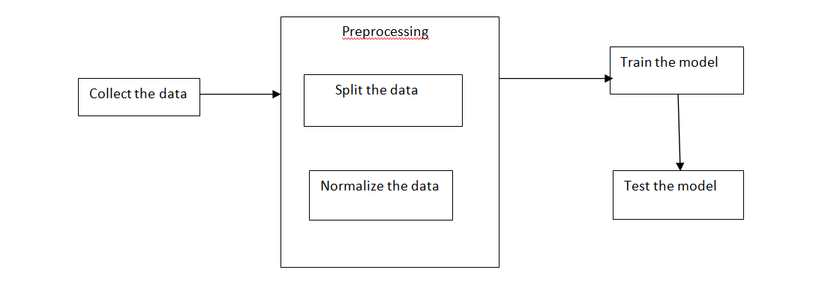

**Class diagrams and classes:**

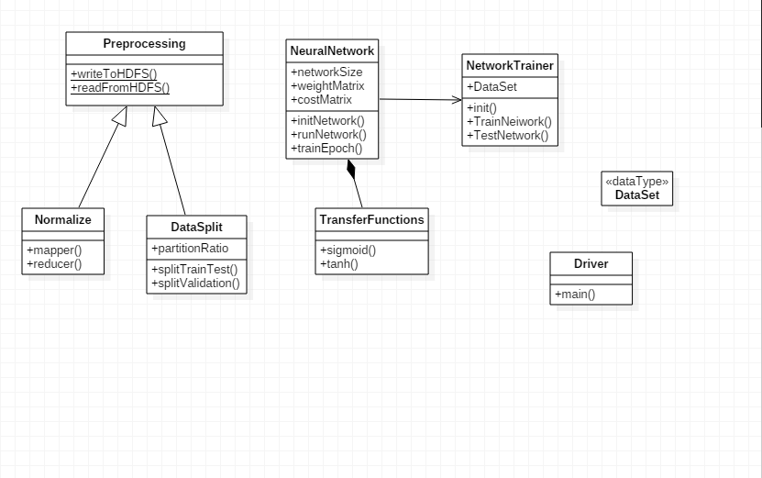

**Sequence diagram:**

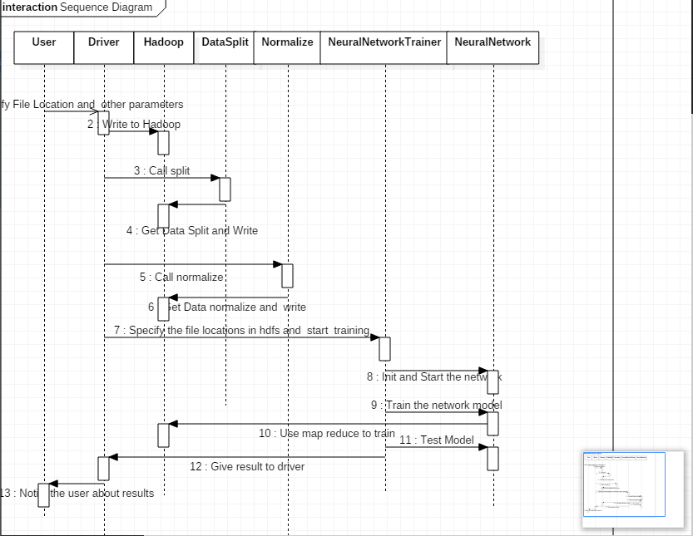

**Data flow diagram:**

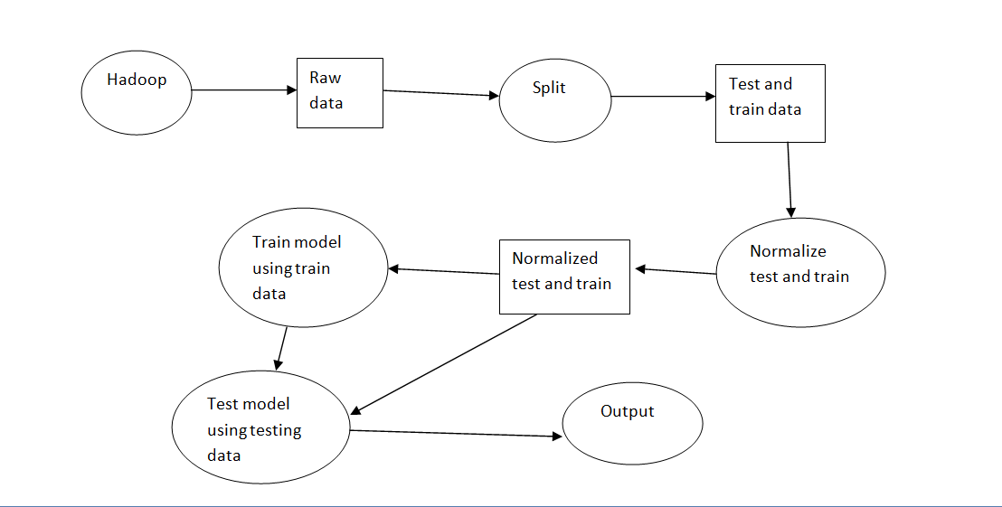

**Implementation**

**Tools introduction:**

**HADOOP:Apache Hadoop** is an open-source software framework written in Java for distributed storage and distributed processing of very large data sets on computer clusters built from commodity hardware. All the modules in Hadoop are designed with a fundamental assumption that hardware failures (of individual machines, or racks of machines) are common and thus should be automatically handled in software by the framework.

The core of Apache Hadoop consists of a storage part, known as Hadoop Distributed File System (HDFS) and a processing part called MapReduce. Hadoop splits files into large blocks and distributes them amongst the nodes in the cluster. To process the data, HadoopMapReduce transfers packaged code for nodes to process in parallel, based on the data each node needs to process. This approach takes advantage of data locality—nodes manipulating the data that they have on hand—to allow the data to beprocessed faster and more efficiently than it would be in a more conventional supercomputer architecture that relies on a parallel file system where computation and data are connected via high-speed networking.

The base Apache Hadoop framework is composed of the following modules:

* *Hadoop Common* – contains libraries and utilities needed by other Hadoop modules;
* *Hadoop Distributed File System (HDFS)* – a distributed file-system that stores data on commodity machines, providing very high aggregate bandwidth across the cluster;
* *Hadoop YARN* – a resource-management platform responsible for managing computing resources in clusters and using them for scheduling of users' applications; and
* *HadoopMapReduce* – a programming model for large scale data processing.

**CARETpackage:**The **caret** package(shortfor *C*lassification *A*nd *Re*gression *T*raining) is a set of functions that attempt to streamline the process for creating predictive models. The package contains tools for:

* data splitting
* pre-processing
* feature selection
* model tuning using resampling
* variable importance estimation

as well as other functionality.

There are many different modeling functions in R. Some have different syntax for model training and/or prediction. The package started off as a way to provide a uniform interface the functions themselves, as well as a way to standardize common tasks (such parameter tuning and variable importance).

**R studio:RStudio** is a free and open source integrated development environment (IDE) for R, a programming language for statistical computing and graphics.

RStudio is available in two editions: RStudio Desktop, where the program is run locally as a regular desktop application; and RStudio Server, which allows accessing RStudio using a web browser while it is running on a remote Linux server. Prepackaged distributions of RStudio Desktop are available for Microsoft Windows, Mac OS X, and Linux.

RStudio is written in the C++ programming language and uses the Qt framework for its graphical user interface.

**Technology introduction:**

**Artificial neural networks:** In machine learning and cognitive science, artificial neural networks (ANNs) are a family of models inspired by biological neural networks (the central nervous systems of animals, in particular the brain) and are used to estimate or approximate functions that can depend on a large number of inputs and are generally unknown. Artificial neural networks are generally presented as systems of interconnected "neurons" which exchange messages between each other. The connections have numeric weights that can be tuned based on experience, making neural nets adaptive to inputs and capable of learning.

For example, a neural network for handwriting recognition is defined by a set of input neurons which may be activated by the pixels of an input image. After being weighted and transformed by a function (determined by the network's designer), the activations of these neurons are then passed on to other neurons. This process is repeated until finally, an output neuron is activated. This determines which character was read.

Like other machine learning methods - systems that learn from data - neural networks have been used to solve a wide variety of tasks that are hard to solve using ordinary rule-based programming, including computer vision and speech recognition**.**

There are many types of artificial neural networks (ANN).

Artificial neural networks are computational models inspired by biological neural networks, and are used to approximate functions that are generally unknown. Particularly, they are inspired by the behaviour of neurons and the electrical signals they convey between input (such as from the eyes or nerve endings in the hand), processing, and output from the brain (such as reacting to light, touch, or heat). The way neurons semantically communicate is an area of ongoing research. Most artificial neural networks bear only some resemblance to their more complex biological counterparts, but are very effective at their intended tasks (e.g. classification or segmentation).

Some ANNs are adaptive systems and are used for example to model populations and environments, which constantly change.

Neural networks can be hardware- (neurons are represented by physical components) or software-based (computer models), and can use a variety of topologies and learning algorithms.

**R studio:** RStudio is a free and open source integrated development environment (IDE) for R, a programming language for statistical computing and graphics.

RStudio is available in two editions: RStudio Desktop, where the program is run locally as a regular desktop application; and RStudio Server, which allows accessing RStudio using a web browser while it is running on a remote Linux server. Prepackaged distributions of RStudio Desktop are available for Microsoft Windows, Mac OS X, and Linux.

RStudio is written in the C++ programming language and uses the Qt framework for its graphical user interface.

**Overall view of the project in terms of implementation:**

A robust system that recognizes face or human body patterns in a given image.Our data set is first normalized using HADOOP and Map Reduce techniques. The normalized data set is then partitioned into training and testing set using CARET(Classification And Regression Analysis) package.

The training data set is used to train the layers of the artificial neural network. Initially a small amount of error is present in the output when compared to the actual output. This is rectified using a technique known as Regression Analysis. Finally, the trained layers are fed with the testing data to analyze the output. Here we find that the output obtained will be as per the required output.

The final product then identifies the human skin or body in an image or a scene when an image is given as the output.

**Explanation of algorithm:**

**Machine learning algorithm used:**

**Backpropogation:** Backpropagation, an abbreviation for "backward propagation of errors", is a common method of training artificial neural networks used in conjunction with an optimization method such as gradient descent. The method calculates the gradient of a loss function with respect to all the weights in the network. The gradient is fed to the optimization method which in turn uses it to update the weights, in an attempt to minimize the loss function.

Backpropagation requires a known, desired output for each input value in order to calculate the loss function gradient. It is therefore usually considered to be a supervised learning method, although it is also used in some unsupervised networks such as autoencoders. It is a generalization of the delta rule to multi-layered feedforward networks, made possible by using the chain rule to iteratively compute gradients for each layer. Backpropagation requires that the activation function used by the artificial neurons (or "nodes") be differentiable.

**Learning algorithm:**

**Gradient descent:** Gradient descent is a first-order optimization algorithm. To find a local minimum of a function using gradient descent, one takes steps proportional to the *negative* of the gradient(or of the approximate gradient) of the function at the current point. If instead one takes steps proportional to the *positive* of the gradient, one approaches a local maximum of that function; the procedure is then known as gradient ascent.

Gradient descent is also known as steepest descent, or the method of steepest descent. However, gradient descent should not be confused with the method of steepest descent for approximating integrals.

**Activation function:**

**Logarithmic sigmoid:** A sigmoid function is a mathematical function having an "S" shape (sigmoid curve). Often, *sigmoid function* refers to the special case of the logistic function shown in the first figure and defined by the formula

**Capture.PNG**

A sigmoid function is a bounded differentiable real function that is defined for all real input values and has a positive derivative at each point.

**Testing**

**Testing and snapshots of results:**

Our project has been successfully tested and implemented on the said platform. The snapshots of the results are as follows

**Screenshots:**

**Data-set:**

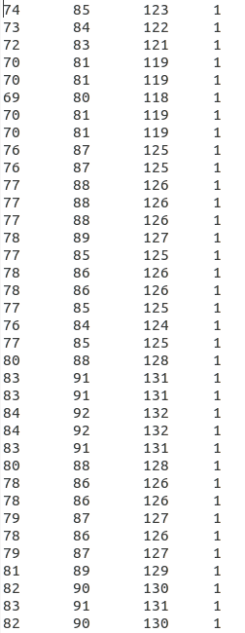

**Normalized data:**

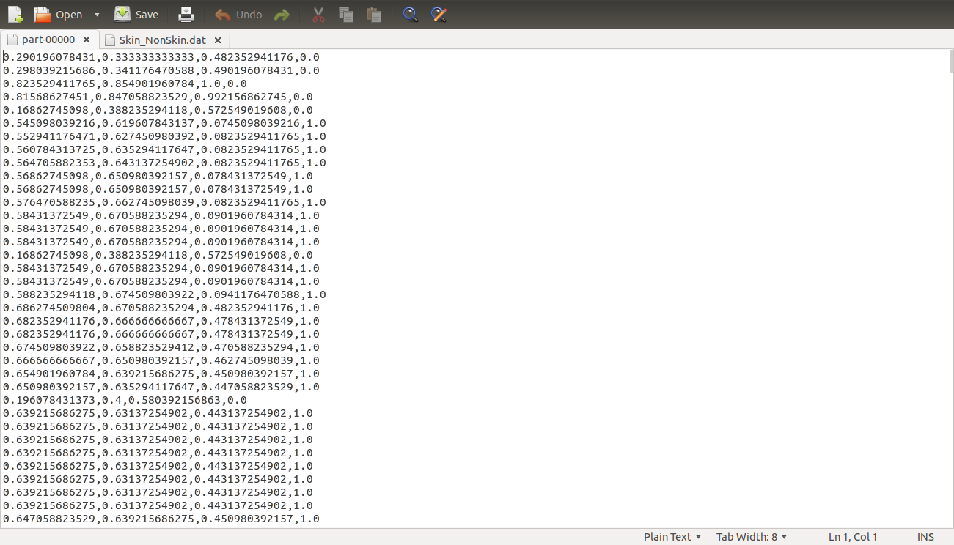

**Output:**

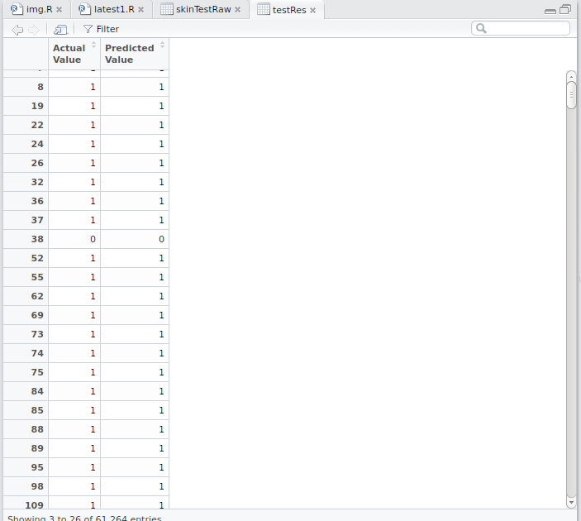

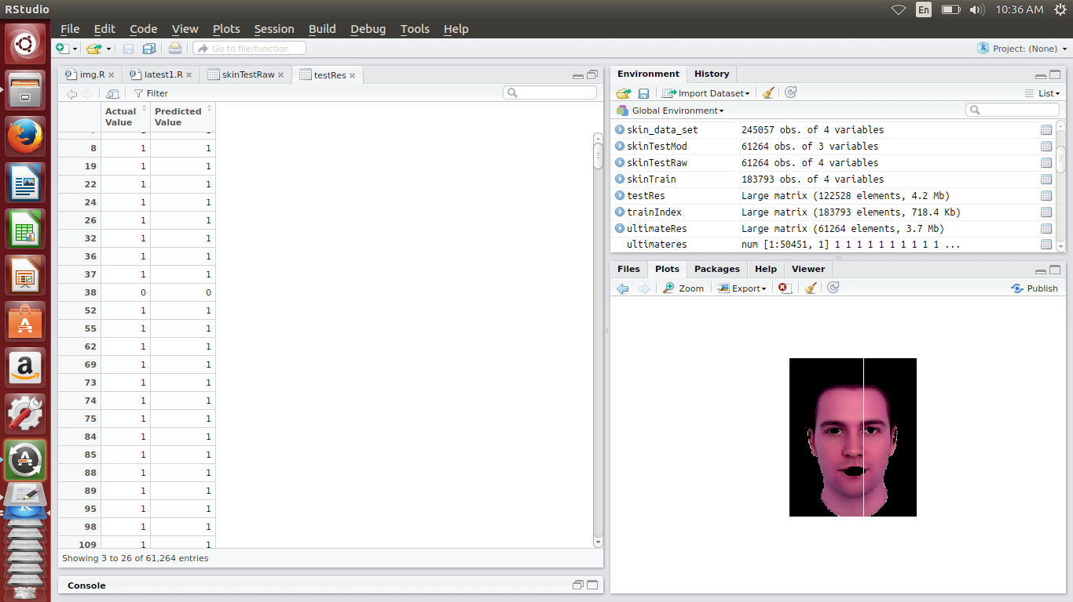

**Conclusion and future scope of the project:**

It can be concluded from the figures bellow that the system gave very encouraging results for both skin and non-skin inputs. The use texture and color feature enhanced the performance of our system and gave recognition accuracy of 96% in the generalization test. This accuracy proves that the texture features are very useful as recognition features for skins in addition to color features that are used in many applications. Figure 4 shows the output from the actual output form the neural network and the desired output which is 1 since the input images are all skin image. It can be seen that only four samples is falsely recognized as non-skin form 50 skin samples, these four samples are shown in figure 6. It can be seen from figure 6 that the images are either taken under lighting conditions that are very different from the lighting conditions under which that training set is taken, or they are not plane skin texture i.e. they contain 3D shadow. This shows the limitations of this method. Figure 5 shows that all the non-skin image samples are truly detected as non skin (NN output of -1) with a very small error that is negligible. The ultimate goal of this work is a system for objectionable image filtering. The future work is to develop algorithms for skin classification (classifying for which part of the body the skin belongs to), and to investigate for appropriate features that can serve for this purpose.

**References:**

**Papers:**

http://www.ijicic.org/ijicic-11-09028.pdf

https://archive.ics.uci.edu/ml/datasets/Skin+Segmentation

http://nichol.as/papers/Vezhnevets/A%20survey%20on%20pixel-based%20skin%20color%20detection.pdf

http://research.ijcaonline.org/volume38/number9/pxc3876881.pdf

http://ieeexplore.ieee.org/xpls/abs_all.jsp?arnumber=6005689&tag=1

http://www.ajer.org/papers/v2(5)/F0255054.pdf

http://citeseerx.ist.psu.edu/viewdoc/download?doi=10.1.1.457.4990&rep=rep1&type=pdf

youtube

wikipedia

R studio tutorials

HADOOP tutorials